training 1 epoch...

3018.264345884323 seconds used......

1 training finished! average train loss: 0.37477609807492485

evaluating...

Confusion matrix, without normalization

[[ 167 350 429]

[ 68 4756 380]

[ 28 307 7111]]

Normalized confusion matrix

[[0.17653277 0.36997886 0.45348837]

[0.01306687 0.91391238 0.07302075]

[0.00376041 0.04123019 0.9550094 ]]

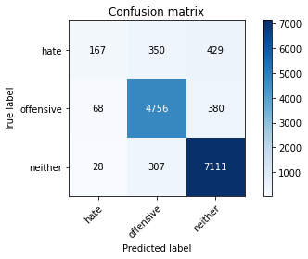

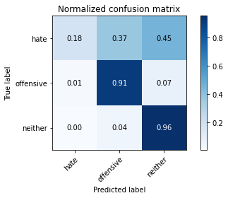

precision recall f1-score support

hate 0.63 0.18 0.28 946

offensive 0.88 0.91 0.90 5204

neither 0.90 0.96 0.93 7446

accuracy 0.89 13596

macro avg 0.80 0.68 0.70 13596

weighted avg 0.87 0.89 0.87 13596

average eval_loss: 0.3247958311016726, accuracy: 0.8851132686084142

training 2 epoch...

3018.8411753177643 seconds used......

2 training finished! average train loss: 0.29853443328153206

evaluating...

Confusion matrix, without normalization

[[ 221 335 390]

[ 83 4753 368]

[ 57 282 7107]]

Normalized confusion matrix

[[0.23361522 0.35412262 0.41226216]

[0.01594927 0.9133359 0.07071483]

[0.00765512 0.03787268 0.9544722 ]]

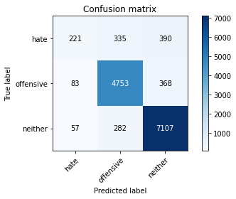

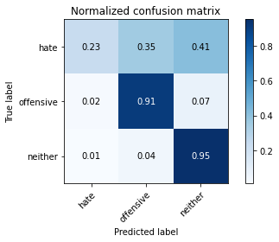

precision recall f1-score support

hate 0.61 0.23 0.34 946

offensive 0.89 0.91 0.90 5204

neither 0.90 0.95 0.93 7446

accuracy 0.89 13596

macro avg 0.80 0.70 0.72 13596

weighted avg 0.88 0.89 0.88 13596

average eval_loss: 0.3266029894050649, accuracy: 0.8885701676963813

training 3 epoch...

3020.793333053589 seconds used......

3 training finished! average train loss: 0.2330566327120392

evaluating...

Confusion matrix, without normalization

[[ 384 239 323]

[ 319 4557 328]

[ 189 306 6951]]

Normalized confusion matrix

[[0.40591966 0.25264271 0.34143763]

[0.061299 0.87567256 0.06302844]

[0.02538276 0.04109589 0.93352135]]

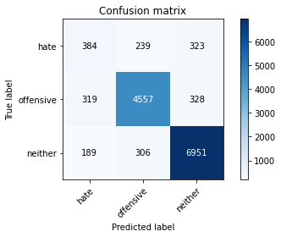

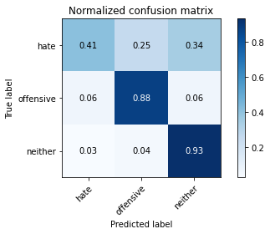

precision recall f1-score support

hate 0.43 0.41 0.42 946

offensive 0.89 0.88 0.88 5204

neither 0.91 0.93 0.92 7446

accuracy 0.87 13596

macro avg 0.75 0.74 0.74 13596

weighted avg 0.87 0.87 0.87 13596

average eval_loss: 0.35752463015344216, accuracy: 0.8746690203000883

add Codeadd Markdown

[22]:

Confusion matrix, without normalization

[[ 750 397 688]

[ 419 4931 575]

[ 464 469 9821]]

Normalized confusion matrix

[[0.40871935 0.21634877 0.37493188]

[0.0707173 0.83223629 0.09704641]

[0.04314674 0.04361168 0.91324158]]

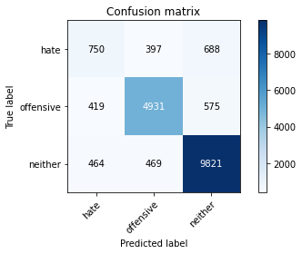

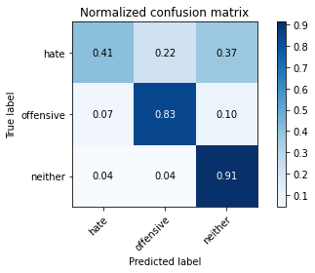

precision recall f1-score support

hate 0.46 0.41 0.43 1835

offensive 0.85 0.83 0.84 5925

neither 0.89 0.91 0.90 10754

accuracy 0.84 18514

macro avg 0.73 0.72 0.72 18514

weighted avg 0.83 0.84 0.83 18514

average eval_loss: 0.48409255441946036, accuracy: 0.8373123042022254

[22]:

0.8373123042022254